Step 2

It was simple to filter for those people in Excel. Overall, there were only 3 actors with the first name Ed. Keeping track of those three rows was simple. I would estimate that it took roughly the same amount of time in PSQL, and the outcomes were same. Additionally, there was not much loading delay in Excel because there are just 200 actors. Due to the small size of the data collection and the ease with which the database request could be implemented in Excel, the work required was equivalent.

Step 3

Column names:

* payment_id
* customer_id
* staff_id
* rental_id
* amount
* payment_date

table names:

* actor
* store
* address
* category
* city
* country
* customer
* film_actor
* film_category
* inventory
* language
* rental
* staff
* payment
* film

That’s the list that was displayed to me. But I used the following querry:

SELECT table_name FROM information_schema.tables

WHERE table_schema = 'public

AND table_type = 'BASE TABLE';

On the left side in the tool we can find the table names, as seen in the following picture:

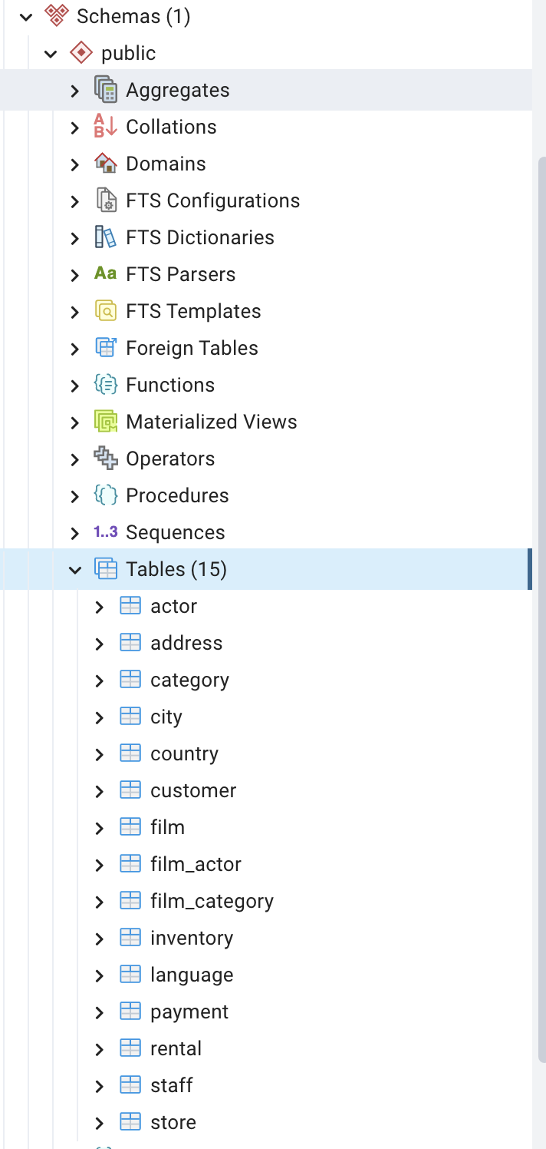

Again I changed the request to:

SELECT rental_duration AS "rented for (in days)", COUNT(*) AS "number of films"

FROM film

GROUP BY 1

ORDER BY 2 DESC

Most films are rented for 6 days.

Step 4

OLAP

* The sales team wants to analyze the sales trend of movies from the last decade. Here only read requests will be made.
* Website developers are working on a new feature displaying the most popular trends. Because of their testing prozess they read a lot of data.

OLTP

* A survey at the end of the logout process was added. Here would an OLTP system be the best, because a lot of data will be created in the future.
* A group of experts from the film industry revise the existing films, correct mistakes and add new films.

Step 5

Item:

| Item_ID | QTY | Description | Price_in_Dollar | Invoice_ID |
| --- | --- | --- | --- | --- |
| 001 | 01 | New Video Collection Licensing | 730 | 2019001 |

Invoice:

| Invoice_ID | client_name | client_address |
| --- | --- | --- |
| 2019001 | MR. Timothy Walker | 40 Sheila LA Sparks, NV |

One could additionally split up the address but I decided not to do so here. Mostly because I didn’t find that address and was not sure how to split it up.